**THEORY**

* The main concept behind the Smart Dustbin using Arduino project is Object Detection.
* A similar methodology is implemented here where the infrared sensor is placed on top of the dustbin’s lid and when the sensor detects any object like a human hand, it will trigger Arduino to open the lid.

**THE COMPONENTS REQUIRED ARE:**

* Arduino UNO
* Infrared Sensor Module
* TowerPro SG90 Servo Motor
* Connecting Wires
* 5V Power Supply
* A small dustbin with lid
* Miscellaneous (glue, plastic tube, etc.)

**CIRCUIT DIAGRAM OF PROPOSED SYSTEM**

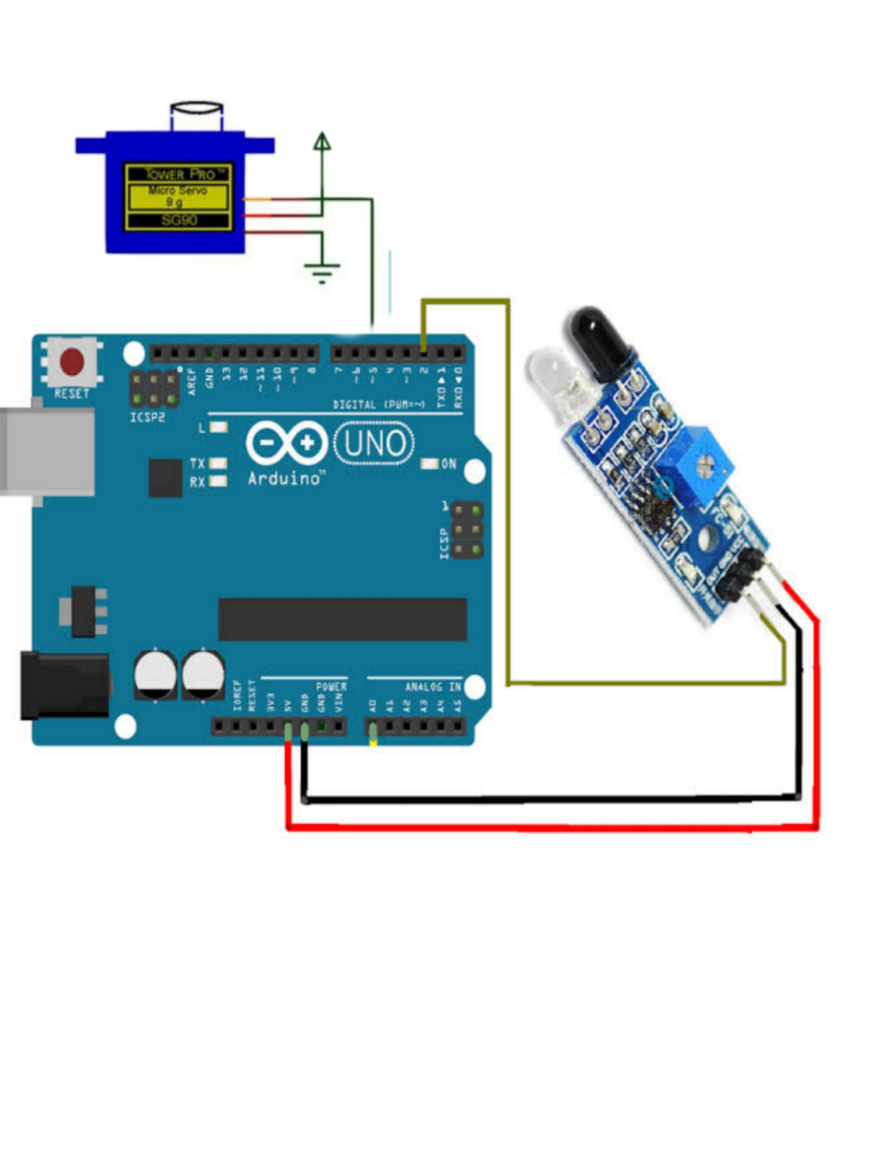

**CONNECTING THE COMPONENTS**

**Connecting the Servo motor**

* Now, let us take you through the actual setup and build process of the Smart Dustbin using Arduino. First, we will start with the mechanism to open the lid. As you might have already guessed, we will be using a Servo Motor for this purpose.
* In order to open the lid, we will be fixing a small plastic tube to the servo horn (a single ended horn) using instant glue.

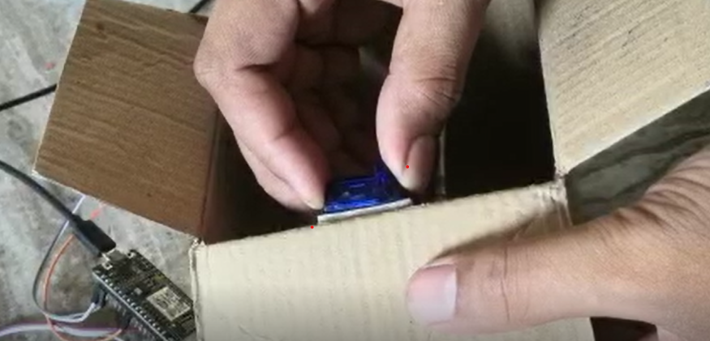

**Connecting the Infrared Sensor:-**

* Once the servo is in position, we can move onto the Infrared Sensor. We will connect it with the Arduino.
* Now, we will connect the pins according to the code and requirement so that it get connected to the Arduino.

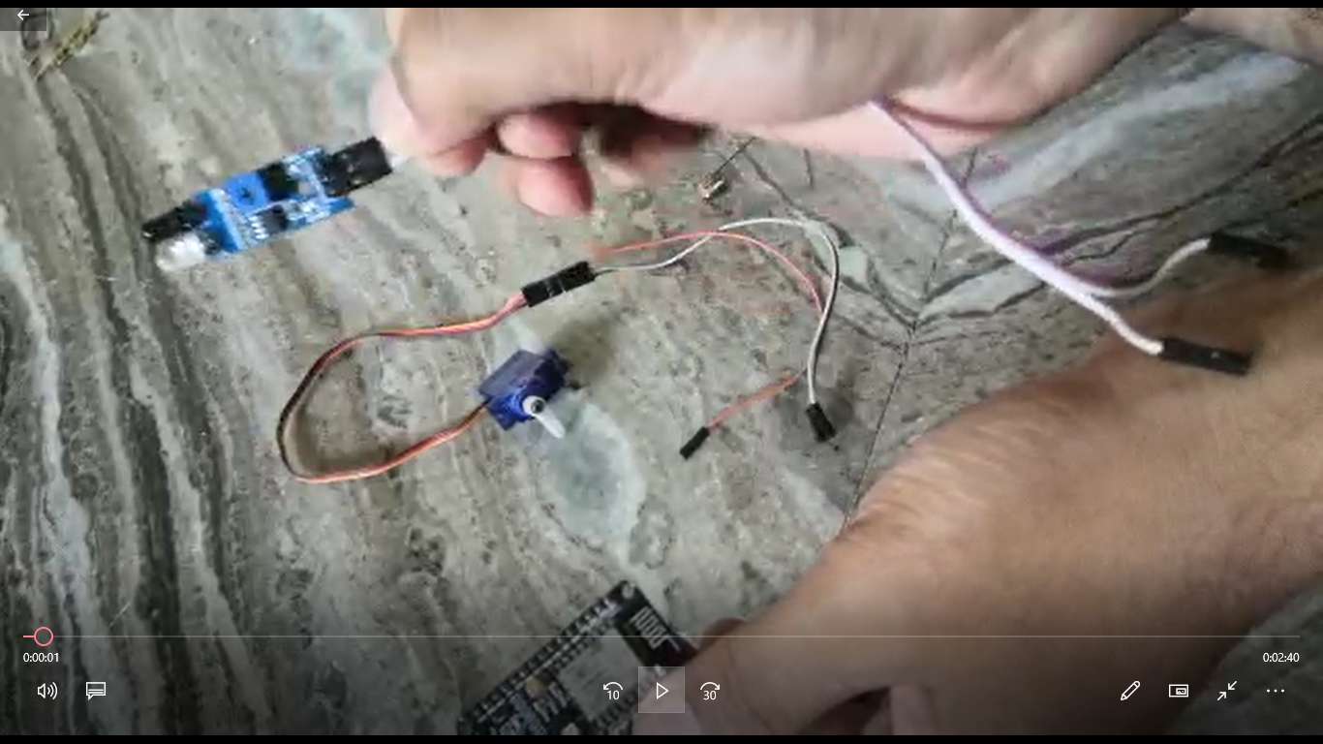

**WIRING THE COMPONENTS..**

* The final step in the build process is to make the necessary connections using long connecting wires as per the circuit diagram and securing these wires so that they don’t hang around.

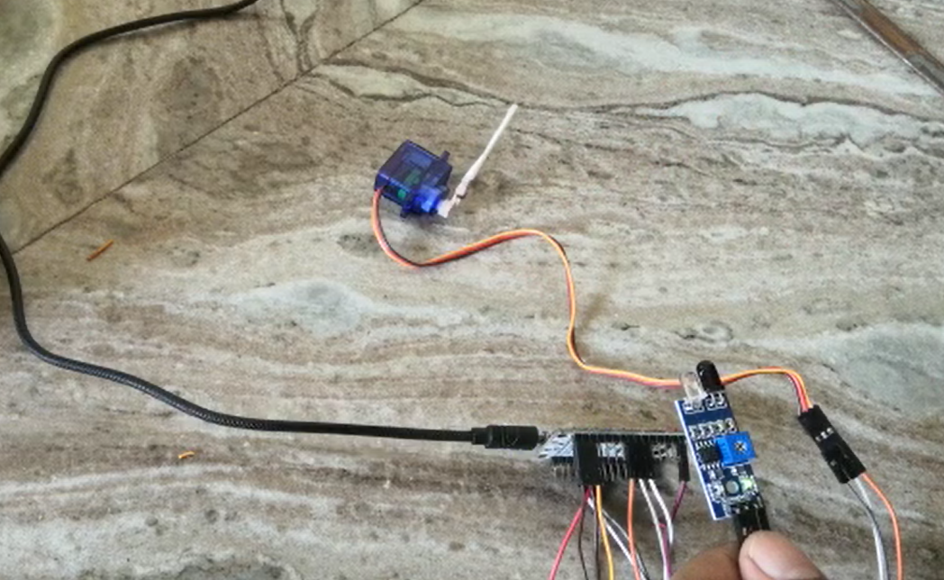

**IMPLEMENTING THE CODE**



**RESULT**

